Comparison between Two Methods of Non-Destructive Evaluation of Standing Trees

Shadabeh FATHI¹, Ferenc DIVOS ² Laszlo BEJO³

¹Institute of Wood Based Products and Technologies, University of Sopron, Hungary
E-mail: shadabe.fathi@gmail.com
²Head, FAKOPP Enterprise, Sopron, Hungary
E-mail: divos@fakopp.hu
³Institute of Wood Based Products and Technologies, University of Sopron, Hungary
E-mail: bejo.laszlo@uni-sopron.hu

Abstract

The main topic of this investigation is the root safety factor (SF) of forest trees, which was measured by dynamic methods. For this purpose, 5 decayed Ash trees were selected from Donaudorf regia in Vienna, Austria. The root stability was measured by the Pulling test and the DynaRoot system. The pulling test involves applying a bending load on the trunk via a cable attached to the tree. The method can be used to assess the uprooting stability of the tree. The dynamic root stability determination (DynaRoot), however, is based on real life wind loads, and therefore more appropriate for assessing real life risks. The results from the two methods were compared to each other. To achieve the best result, the crown surface was estimated from pictures using the ArborSonic 3D software and the results added to pulling test data for error minimization. The results from the two types of equipment correlated relatively well This means that both pieces of equipment are useful and safe for measuring the root stability of trees.

Keywords: Pulling Test, DynaRoot system, Safety Factor, ArborSonic, Ash trees

1. Introduction

Dynamic analysis is a term used in software engineering to describe the testing of the dynamic behavior of code [7]. Dynamic analysis may also refers to the examination of the physical response from the system to variables that are not constant and change with time.
The sun provides light for plants. Plants provide food for animals that are, in turn, consumed by other animals. Therefore, destroying the environment would disrupt the food chain system. Ensuring the safety of trees can help protecting all of the valuable components of the ecosystem. The dynamic method offers an efficient way to achieve this goal. Forests play a key role in mitigating or preventing the impact of a natural hazards, including falling rocks, avalanches, erosion, landslide, debris flow or flooding, on people and their assets in mountainous areas. A protection forest generally covers the sloping area between a hazard potential (e.g. an unstable rock cliff or an avalanche release zone) and the endangered or exposed assets. In the Alps, protection forests are increasingly considered equal to engineered mitigation measures against natural hazards. Some European countries consider trees important in protecting soil and to preventing it from eroding or blowing away. Austrian law differentiates between a protected forest (Schutzwald) and a protection forest (Bannwald). A protected forest is largely protecting the natural features of the forest itself. Whereas a protection forest is seen as also having a protective function, it is specifically said to protect against a concrete threat that is specified in the Bann or protection order. [1] Nowadays, there are many ways for protect and predict the defects.
The dynamic evaluation is clearly safer and more functional than the static tests. An excellent literature review by Kent et al. [5] summarizes research activity in dynamic tree evaluation These models rely on physical models or finite element modeling and account for many of the species, crown area, age, pruning, site conditions, climate and seasonal factors. However, taking all of these factors in consideration is not possible from a practical point of view. [4, 5, 6] The behavior of a tree in the wind is highly sensitive to the initial conditions. Small differences in initial conditions yield widely diverging outcomes for such dynamic systems (a situation popularly referred to as “the butterfly effect”). It is impossible to predict the behavior of such systems on the long run. A definite relationship exists between the wind velocity and the inclination of the tree, but it is a complex relationship, not one of immediate cause and effect. One way to evaluate such systems is using statistical parameters of the data taken over longer intervals. There is no immediate relationship between the wind velocity and the inclination at any given moment, but there is a relationship between their averages and other statistical parameters observed over a longer interval. Our goal was to evaluate the root stability of trees using both static and dynamic tests, and compare the results.

2. Pulling test [3]
The pulling test (see (figure 1) consists of:
- Cable and winch: our system contains a 20-meter length of high capacity metal cable with a 1.6 metric ton manually operated winch. The winch has a ratchet mechanism that multiplies the force of the operator to exert sufficient tension on the cable. The cable and the winch were equipped with safety hooks and two soft belts for fitting it around the tree trunk and the anchor point.
- Load cell.: calibrated cable-mounted load cell, 5T capacity with a sampling rate of 1 Hz.
- Inclinometer: biaxial inclinometer sensor, ST-015 mounted on the tree collar with a measurement range of ± 2 degrees, and a Resolution of 0.001 degree.

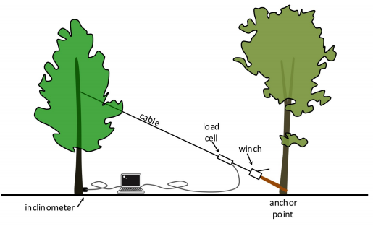
Figure 1- Schematic view of Pulling test

The pulling test is based on affixing a cable at approximately mid-height to the tree to be evaluated, and applying a moderate load, while measuring the inclination at the base of the trunk. The induced inclination is slight (less than .25 degrees), to make sure that the test itself does not damage or start uprooting the tree. The cable is attached to the tree at approximately mid-height in the crown. This typically requires a ladder, or climbing the tree to the appropriate height. A metal cable of appropriate loading capacity is attached to the trunk. A soft belt is typically used for this to avoid damaging the tree. The other end of the cable enters a winch, which is affixed to an anchor point. The anchor point can be any object that is safely secured to the ground, most often a stump or the bottom of another tree. If another tree is used, care should be taken that the bark is not damaged. The winch applies tension to the cable. A load cell attached to the cable measures the tensile load. Since the cable is at an angle, the horizontal component of the load is calculated and used for the evaluation.
Load and inclination is continually measured throughout the measurement and sent to a computer for recording and evaluation. The instruments send the data is to a computer where it is evaluated real time and also recorded. The recorded load and inclination data provides the inclination curve, which can be approximated using a special tangential function. The maximum load – and from that, the maximum torque – required for uprooting the tree can be estimated by extrapolating this curve. From this value, a so-called safety factor (SF) can be calculated, as explained in detail in [3]. SF is always calculated with reference to a given wind velocity, taking the crown surface area and other parameters into account. A SF below one means that the reference wind velocity is likely to uproot the tree. When SF above 1.5 are considered safe, and in-between these two values there is a region of uncertainty [2].

3. DynaRoot [3]

The DynaRoot system consists of three components (see Figure 2):
- Anemometer: an instrument for measuring wind velocity at or near the tree to be evaluated. The closer to the better, but, depending on wind velocity DynaRoot may provide reliable data even with measurements taken several kilometers away. Ideally the anemometer should be clear of buildings or other objects that may obstruct the wind, at a height of at least 10 m.
- Inclinometer (the same as used in the pulling test)
- Evaluation software: a PC software for evaluating wind velocity, x and y inclination. The data, recorded over a period of several hours, are transferred from the anemometer and inclinometer on memory cards or wirelessly. The software breaks the data down into batches based on intervals of several minutes, and calculates statistical parameters for each batch. These statistical parameters are used for the tree stability evaluation.

The Safety Factor calculation is similar to that in the pulling test, except, in this case, wind pressure is used instead of force, and statistical parameters are used, instead of the momentary wind pressure and inclination values. There is a tangential relationship between the wind pressure and the inclination of the tree, and the critical wind pressure can be calculated from the curves. This critical value is used for calculating the SF, which is interpreted the same way as the one calculated from the static pulling test.
The following conditions were observed during the measurements:
- The distance between the measured trees and the anemometer, was less than 1 km.
- Wind velocity, was between 40 and 50 km/h
- Wind load and inclination data was statistically evaluated based on 10 min intervals.
- All of the trees were measured on the same day, and the wind direction was 45 degrees off east (NE).

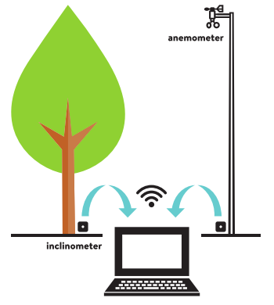
Figure 2- Schematic view of DynaRoot system

The reference wind velocity for the safety factor calculation was 33 m/s (approx. 120 km/h)

In this study, 5 severely decayed ash trees were evaluated whose SF was likely to be low at the reference wind velocity. Before the analysis of the pulling test data, the crown surface and crown center height values were calculated using the ArborSonic 3D software, which can calculate the crown surface and crown center height of a tree based on photographs. The crown surface was added to the results of pulling test, and then results obtained from DynaRoot and the Pulling test were compared to each other.

4. Result and discussion

Figure 3 shows sample output information from the Arborsonic software (crown surface determination), the pulling test and the dynaroot system.
After completing the pulling test and Dynaroot system, the safety factors were calculated based on both for each tree, and compared to each other. The results are plotted in Figure 4. The diagram shows relatively good agreement between the two sets of results, although the safety factors calculated from the pulling test were generally somewhat higher than those based on DynaRoot. There are several possible reasons for the discrapancies:

- Pulling direction was not exactly the same as the wind direction. It was not always possible to find an anchorage point in exactly the prevalent wind direction.
- Dynamic testing is affected by nearby objects (other trees) that may provide some shading from the effect of the wind, while the pulling test does not take these into consideration
- Because dynamic testing results show a greater degree of variability, SF calculation is based on the lower confidence limit of the results, which accounts for the lower SF values calculated by this method.
- Finally, the different nature of the two measurements will inevitably lead to some differences in the results.

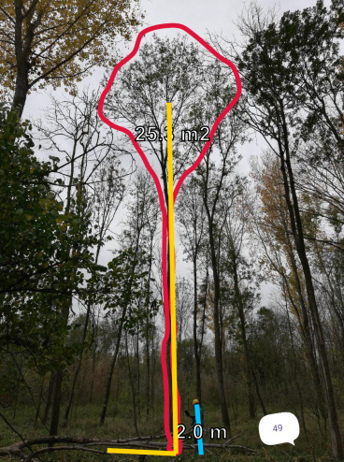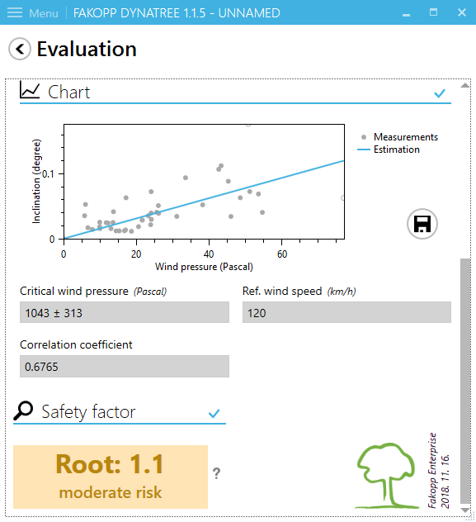
A) B)

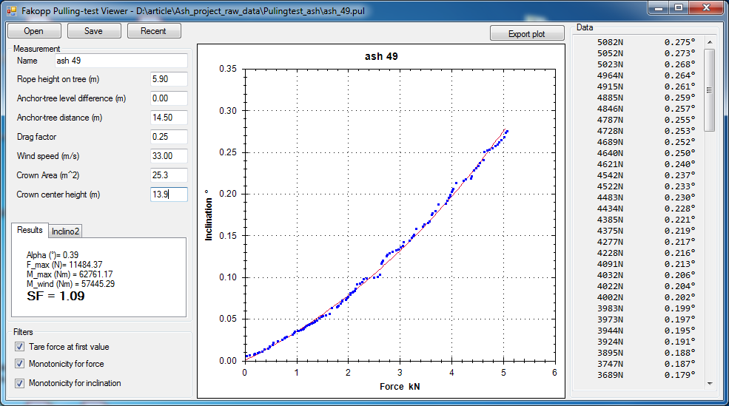
C)
Figure 3 The result of tree Nr. 1. A) Crown Surface and crown midpoint height is calculated using the Arborsonic software B) DynaRoot results analysis C) Pulling test curve analysis

Figure 4 - Comparing the SFs obtained from Pulling test and DynaRoot system

Despite the discrepancies between the two systems, the SF values in Figure 4 show a relatively good correlation. Without actually uprooting the trees, it is difficult to assess which method is more accurate. However, Dynaroot provides a more conservative estimate, and the low SF values are likely to be closer to reality, as the examined trees were severely decayed.

Another way of comparing the pulling test and the DynaRoot system is by calculating the critical torque values, at which the tree is predicted to be uprooted. The critical torque is actually part of the output of the pulling test analysis. It may also be calculated from the DynaRoot results, based on the critical pressure, using the crown surface area and midpoint height, also taking the so-called aerodynamic drag factor into consideration. Table 1 shows the results of the analysis.

Table 1- Detailed results obtained by the Pulling test and the DynaRoot system
Tree Nr. |  | 1 | 2 | 3 | 4 | 5
ArborSonic | A (m²) | 25.3 | 27.2 | 21.3 | 13 | 9.4
 | cch (m) | 13.9 | 14.1 | 11 | 11 | 8.7
Pulling test | F_{max} (N) | 11484 | 13245 | 22113 | 5889 | 4817
 | M_{max} (Nm) | 62761 | 64401 | 116732 | 30815 | 24695
DynaRoot | P_{crit} (Pa) | 1043  ±313 | 572  ±144 | 1460  ±383 | 476  ±94 | 1329  ±1038
 | F_{crit} (N) | 6596 | 3889 | 7774 | 1547 | 3123
 | M_{crit} (Nm) | 91697 | 54843 | 85519 | 17017 | 27171
A – crown surface area, cch – crown centerpoint height F_{max}, M_{max} = Predicted uprooting force and torque, pulling test; P_{crit}, F_{crit}, M_{crit} = Predicted uprooting pressure, force and torque, DynaRoot

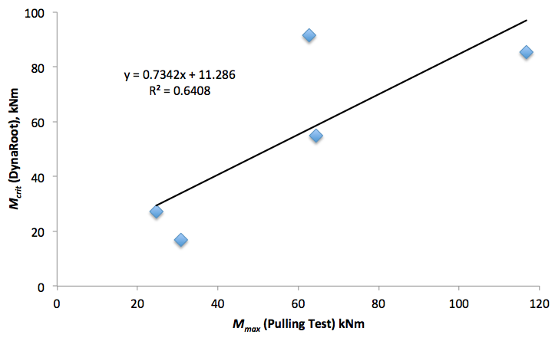

Figure 5 - the compare between the Torque of Dynaroot system and Torque of pulling test

The critical torque values determined based on the two stability evaluation methods showed very good correlation (Figure 5). The correlation coefficient was 0.64, which is acceptable when dealing with natural materials with a high degrees of variabilty. In most cases Dynaroot provided similar or lower uprooting torque values, which further confirms that Dynaroot provides a more conservative estimate for the stability of trees.

Conclusions

5 severely decayed Ash (Fraxinus Excelsior) trees were evaluated for stability using the traditional pulling test and an innovative dynamic tree stability evaluation method. The comparision of the two methods yielded the following conclusions:
- The two methods yielded different, but comparable Safety Factor (SF) values at the same reference wind velocity level. Differences were due to differences in measurement direction, the effect of possible shielding on dynamic measurements, and differences inhetent in the two methods.
- The dynamic method provides more conservative SF values.
- Uprooting torque estimates correlate reasonably well between the two methods (R² = 0.64) The dynamic method, again, typically, but not consistenty, provided more conservative estimates.

Further investigations, including the measurement of actual uprooting force, will provide more of the necessary evidence for the reliability of the two methods.

Acknowledgments
The research described in this article/study was carried out as part of the project GINOP-2.3.3-15-2016-00038, "Further processing of wood and wood products based on green chemistry and technology, through creating modern research infrastructure" in the framework of the Széchenyi2020 Programme. The implementation of this project is supported by the European Union, co-financed by the European Regional Development Fund.
Instruments, including Arborsonic and DynaRoot, were supplied by FAKOPP enterprise

References
- Bundesgezetz vom 3. Juli 1975, mit dem das Forstwesen geregelt wird (Forstgezetz 1975) (Austrian Forest Law)
- Bejó, L., F. Divós, S. Fathi. 2017. Dynamic root stability assessment – basics and practical examples. In: Proc. 20th International Nondestructive Testing and Evaluation of Wood Symposium. Madison (WI), USA, 2017.09.12-15. 7pp.
- Fakopp Ltd., DynaRoot Dynamic Root Evaluation System, User’s manual http://fakopp.com/docs/products/dynaroot/UserManualDynaRoot.pdf
- Baker, C.J., and H.J. Bell. 1992. Aerodynamics of urban trees. Journal of Wind Engineering and Industrial Aerodynamics 44:2655–2666.
- James, Kent.R., N. Haritos, and P.K. Addes. 2006. Mechanical stability of trees under dynamic loads. American Journal of Botany 93(10):1361–1369.
- Moore, J.R., and D.A. Maguire. 2008. Simulating the dynamic behavior of Douglas-fir trees under applied loads by the finite element method. Tree Physiology 28:75–83
- Gergely T, Balogh G, Horvath F, Vancsics B, Beszedes A, Tibor Gyimothy, 2018 Differences between a static and a dynamic test-to-code traceability recovery method, Software Quality Journal https://doi.org/10.1007/s11219-018-9430-x , Springe

